Lecture Notes in Computer Science: Authors’ Instructions for the Preparation of Camera-Ready Contributions

to LNCS/LNAI/LNBI Proceedings

Alfred Hofmann?, Brigitte Apfel, Ursula Barth, Christine G¨unther, Ingrid Haas, Frank Holzwarth, Anna Kramer, Leonie Kunz, Nicole Sator, Erika Siebert-Cole, and Peter Straßer

Springer-Verlag, Computer Science Editorial,

Tiergartenstr. 17, 69121 Heidelberg, Germany

{alfred.hofmann,brigitte.apfel,ursula.barth,christine.guenther, ingrid.haas,frank.holzwarth,anna.kramer,leonie.kunz,nicole.sator, erika.siebert-cole,peter.strasser,lncs}@springer.com http://www.springer.com/lncs

Abstract. The abstract should summarize the contents of the paper and should contain at least 70 and at most 150 words. It should be written using the abstract environment.

Key words: We would like to encourage you to list your keywords within the abstract section

1 Introduction

You are strongly encouraged to use L^{A}T_{E}X 2_{ε} for the preparation of your camera-ready manuscript together with the corresponding Springer class file llncs.cls. Only if you use L^{A}T_{E}X 2_{ε} can hyperlinks be generated in the online version of your manuscript.

The L^{A}T_{E}X source of this instruction file for L^{A}T_{E}X users may be used as a tem-plate. This is located in the “authors” subdirectory in ftp://ftp.springer.de/ pub/tex/latex/llncs/latex2e/instruct/ and entitled typeinst.tex. There is a separate package for Word users. Kindly send the final and checked source and PDF files of your paper to the Contact Volume Editor. This is usually one of the organizers of the conference. You should make sure that the L^{A}T_{E}X and the PDF files are identical and correct and that only one version of your paper is sent. It is not possible to update files at a later stage. Please note that we do not need the printed paper.

- Please note that the LNCS Editorial assumes that all authors have used the west-ern naming convention, with given names preceding surnames. This determines the structure of the names in the running heads and the author index.

2 Lecture Notes in Computer Science: Authors’ Instructions

We would like to draw your attention to the fact that it is not possible to modify a paper in any way, once it has been published. This applies to both the printed book and the online version of the publication. Every detail, including the order of the names of the authors, should be checked before the paper is sent to the Volume Editors.

1.1 Checking the PDF File

Kindly assure that the Contact Volume Editor is given the name and email address of the contact author for your paper. The Contact Volume Editor uses these details to compile a list for our production department at SPS in India. Once the files have been worked upon, SPS sends a copy of the final pdf of each paper to its contact author. The contact author is asked to check through the final pdf to make sure that no errors have crept in during the transfer or preparation of the files. This should not be seen as an opportunity to update or copyedit the papers, which is not possible due to time constraints. Only errors introduced during the preparation of the files will be corrected.

This round of checking takes place about two weeks after the files have been sent to the Editorial by the Contact Volume Editor, i.e., roughly seven weeks before the start of the conference for conference proceedings, or seven weeks before the volume leaves the printer’s, for post-proceedings. If SPS does not receive a reply from a particular contact author, within the timeframe given, then it is presumed that the author has found no errors in the paper. The tight publication schedule of LNCS does not allow SPS to send reminders or search for alternative email addresses on the Internet.

In some cases, it is the Contact Volume Editor that checks all the final pdfs. In such cases, the authors are not involved in the checking phase.

1.2 Additional Information Required by the Volume Editor

If you have more than one surname, please make sure that the Volume Editor knows how you are to be listed in the author index.

1.3 Copyright Forms

The copyright form may be downloaded from the “For Authors” (Information for LNCS Authors) section of the LNCS Website: www.springer.com/lncs. Please send your signed copyright form to the Contact Volume Editor, either as a scanned pdf or by fax or by courier. One author may sign on behalf of all of the other authors of a particular paper. Digital signatures are acceptable.

2 Paper Preparation

Springer provides you with a complete integrated L^{A}T_{E}X document class (llncs.cls) for multi-author books such as those in the LNCS series. Papers not complying

Lecture Notes in Computer Science: Authors’ Instructions 3

with the LNCS style will be reformatted. This can lead to an increase in the overall number of pages. We would therefore urge you not to squash your paper.

Please always cancel any superfluous definitions that are not actually used in your text. If you do not, these may conflict with the definitions of the macro package, causing changes in the structure of the text and leading to numerous mistakes in the proofs.

If you wonder what L^{A}T_{E}X is and where it can be obtained, see the “La-TeX project site” (http://www.latex-project.org) and especially the web-page “How to get it” (http://www.latex-project.org/ftp.html) respectively.

When you use L^{A}T_{E}X together with our document class file, llncs.cls, your text is typeset automatically in Computer Modern Roman (CM) fonts. Please do not change the preset fonts. If you have to use fonts other than the preset fonts, kindly submit these with your files.

Please use the commands \label and \ref for cross-references and the com-mands \bibitem and \cite for references to the bibliography, to enable us to create hyperlinks at these places.

For preparing your figures electronically and integrating them into your source file we recommend using the standard L^{A}T_{E}X graphics or graphicx pack-age. These provide the \includegraphics command. In general, please refrain from using the \special command.

Remember to submit any further style files and fonts you have used together with your source files.

Headings. Headings should be capitalized (i.e., nouns, verbs, and all other words except articles, prepositions, and conjunctions should be set with an initial capital) and should, with the exception of the title, be aligned to the left. Words joined by a hyphen are subject to a special rule. If the first word can stand alone, the second word should be capitalized.

Here are some examples of headings: “Criteria to Disprove Context-Freeness of Collage Language”, “On Correcting the Intrusion of Tracing Non-deterministic Programs by Software”, “A User-Friendly and Extendable Data Distribution System”, “Multi-flip Networks: Parallelizing GenSAT”, “Self-determinations of Man”.

Lemmas, Propositions, and Theorems. The numbers accorded to lemmas, propositions, and theorems, etc. should appear in consecutive order, starting with Lemma 1, and not, for example, with Lemma 11.

2.1 Figures

For L^{A}T_{E}X users, we recommend using the graphics or graphicx package and the
\includegraphics command.
Please check that the lines in line drawings are not interrupted and are of a constant width. Grids and details within the figures must be clearly legible and may not be written one on top of the other. Line drawings should have

4 Lecture Notes in Computer Science: Authors’ Instructions

a resolution of at least 800 dpi (preferably 1200 dpi). The lettering in figures should have a height of 2 mm (10-point type). Figures should be numbered and should have a caption which should always be positioned under the figures, in contrast to the caption belonging to a table, which should always appear above the table; this is simply achieved as matter of sequence in your source.

Please center the figures or your tabular material by using the \centering declaration. Short captions are centered by default between the margins and typeset in 9-point type (Fig. 1 shows an example). The distance between text and figure is preset to be about 8 mm, the distance between figure and caption about 6 mm.

To ensure that the reproduction of your illustrations is of a reasonable quality, we advise against the use of shading. The contrast should be as pronounced as possible.

If screenshots are necessary, please make sure that you are happy with the print quality before you send the files.

0.025
0.02
0.015
0.01
0.005
0
−25 | −20 | −15 | −10 | −5 | 0 | 5 | 10
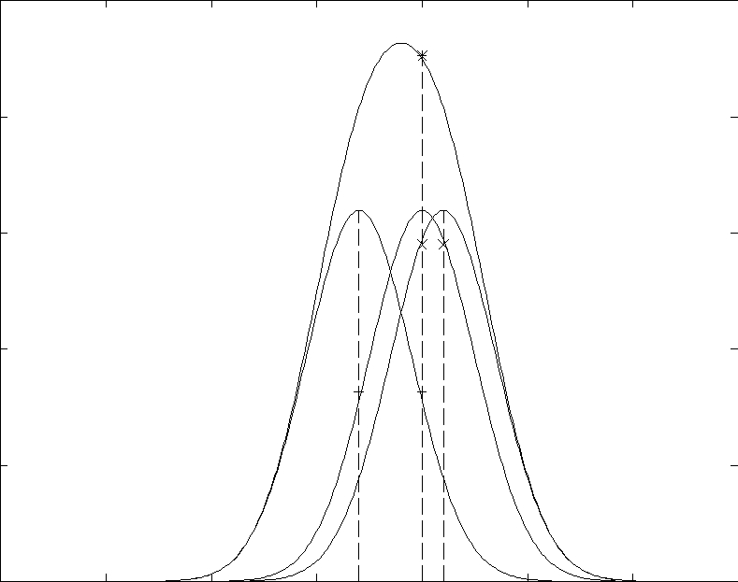
Xi XsXj

Fig. 1. One kernel at x_{s} (dotted kernel ) or two kernels at x_{i} and x_{j} (left and right ) lead to the same summed estimate at x_{s}. This shows a figure consisting of di erent types of lines. Elements of the figure described in the caption should be set in italics, in parentheses, as shown in this sample caption.

Please define figures (and tables) as floating objects. Please avoid using op-tional location parameters like “[h]” for “here”.

Remark 1. In the printed volumes, illustrations are generally black and white (halftones), and only in exceptional cases, and if the author is prepared to cover the extra cost for color reproduction, are colored pictures accepted. Colored pictures are welcome in the electronic version free of charge. If you send colored figures that are to be printed in black and white, please make sure that they

Lecture Notes in Computer Science: Authors’ Instructions 5

really are legible in black and white. Some colors as well as the contrast of converted colors show up very poorly when printed in black and white.

2.2 Formulas

Displayed equations or formulas are centered and set on a separate line (with an extra line or halfline space above and below). Displayed expressions should be numbered for reference. The numbers should be consecutive within each section or within the contribution, with numbers enclosed in parentheses and set on the right margin – which is the default if you use the equation environment, e.g.,
ψ(u) = _{o}^{T} ^{Ž} | 2¹ |  | Λ_{o}⁻¹u, u + N ∗(−u)^{₃} dt . | (1)
 |  | ₃
Equations should be punctuated in the same way as ordinary text but with a small space before the end punctuation mark.

2.3 Footnotes

The superscript numeral used to refer to a footnote appears in the text either directly after the word to be discussed or – in relation to a phrase or a sentence – following the punctuation sign (comma, semicolon, or period). Footnotes should appear at the bottom of the normal text area, with a line of about 2 cm set immediately above them.¹

2.4 Program Code

Program listings or program commands in the text are normally set in typewriter font, e.g., CMTT10 or Courier.

Example of a Computer Program

program Inflation (Output)

{Assuming annual inflation rates of 7%, 8%, and 10%,...

years}; const

MaxYears = 10; var

Year: 0..MaxYears;

Factor1, Factor2, Factor3: Real; begin

Year := 0;

Factor1 := 1.0; Factor2 := 1.0; Factor3 := 1.0; WriteLn(’Year 7% 8% 10%’); WriteLn;

¹ The footnote numeral is set flush left and the text follows with the usual word spacing.

6 Lecture Notes in Computer Science: Authors’ Instructions

repeat

Year := Year + 1;

Factor1 := Factor1 * 1.07;

Factor2 := Factor2 * 1.08;

Factor3 := Factor3 * 1.10; WriteLn(Year:5,Factor1:7:3,Factor2:7:3,Factor3:7:3)

until Year = MaxYears

end.

(Example from Jensen K., Wirth N. (1991) Pascal user manual and report. Springer, New York)

2.5 Citations

For citations in the text please use square brackets and consecutive numbers: [1], [2], [4] – provided automatically by L^{A}T_{E}X’s \cite . . . \bibitem mechanism.

2.6 Page Numbering and Running Heads

There is no need to include page numbers. If your paper title is too long to serve as a running head, it will be shortened. Your suggestion as to how to shorten it would be most welcome.

3 LNCS Online

The online version of the volume will be available in LNCS Online. Members of institutes subscribing to the Lecture Notes in Computer Science series have access to all the pdfs of all the online publications. Non-subscribers can only read as far as the abstracts. If they try to go beyond this point, they are automatically asked, whether they would like to order the pdf, and are given instructions as to how to do so.

Please note that, if your email address is given in your paper, it will also be included in the meta data of the online version.

4 BibTeX Entries

The correct BibTeX entries for the Lecture Notes in Computer Science volumes can be found at the following Website shortly after the publication of the book: http://www.informatik.uni-trier.de/~ley/db/journals/lncs.html

Acknowledgments. The heading should be treated as a subsubsection heading and should not be assigned a number.

Lecture Notes in Computer Science: Authors’ Instructions 7

5 The References Section

In order to permit cross referencing within LNCS-Online, and eventually between di erent publishers and their online databases, LNCS will, from now on, be standardizing the format of the references. This new feature will increase the visibility of publications and facilitate academic research considerably. Please base your references on the examples below. References that don’t adhere to this style will be reformatted by Springer. You should therefore check your references thoroughly when you receive the final pdf of your paper. The reference section must be complete. You may not omit references. Instructions as to where to find a fuller version of the references are not permissible.

We only accept references written using the latin alphabet. If the title of the book you are referring to is in Russian or Chinese, then please write (in Russian) or (in Chinese) at the end of the transcript or translation of the title.

The following section shows a sample reference list with entries for journal articles [1], an LNCS chapter [2], a book [3], proceedings without editors [4] and [5], as well as a URL [6]. Please note that proceedings published in LNCS are not cited with their full titles, but with their acronyms!

References

- Smith, T.F., Waterman, M.S.: Identification of Common Molecular Subsequences. J. Mol. Biol. 147, 195–197 (1981)

- May, P., Ehrlich, H.C., Steinke, T.: ZIB Structure Prediction Pipeline: Composing a Complex Biological Workflow through Web Services. In: Nagel, W.E., Walter, W.V., Lehner, W. (eds.) Euro-Par 2006. LNCS, vol. 4128, pp. 1148–1158. Springer, Heidelberg (2006)

- Foster, I., Kesselman, C.: The Grid: Blueprint for a New Computing Infrastructure. Morgan Kaufmann, San Francisco (1999)

- Czajkowski, K., Fitzgerald, S., Foster, I., Kesselman, C.: Grid Information Services for Distributed Resource Sharing. In: 10th IEEE International Symposium on High Performance Distributed Computing, pp. 181–184. IEEE Press, New York (2001)

- Foster, I., Kesselman, C., Nick, J., Tuecke, S.: The Physiology of the Grid: an Open Grid Services Architecture for Distributed Systems Integration. Technical report, Global Grid Forum (2002)

- National Center for Biotechnology Information, http://www.ncbi.nlm.nih.gov

Appendix: Springer-Author Discount

LNCS authors are entitled to a 33.3% discount o all Springer publications. Before placing an order, the author should send an email, giving full details of his or her Springer publication, to orders-HD-individuals@springer.com to obtain a so-called token. This token is a number, which must be entered when placing an order via the Internet, in order to obtain the discount.

8 Lecture Notes in Computer Science: Authors’ Instructions

6 Checklist of Items to be Sent to Volume Editors

Here is a checklist of everything the volume editor requires from you:

- The final L^{A}T_{E}X source files

- A final PDF file

- A copyright form, signed by one author on behalf of all of the authors of the paper.

- A readme giving the name and email address of the corresponding author.

